Experiment 8: Scaling an Image to its Bigger and Smaller Sizes
Aim
To perform image scaling using Python and OpenCV by resizing an image to both larger and smaller dimensions.
Software Requirements
- Python 3.x
- OpenCV (cv2)
- Visual Studio Code / PyCharm / Jupyter Notebook
Procedure
- Install the OpenCV library using pip install opencv-python.
- Import the OpenCV library.
- Read the input image using cv2.imread().
- Display the original image.
- Resize the image to a larger size using cv2.resize() with a scaling factor greater than 1.
- Resize the image to a smaller size using cv2.resize() with a scaling factor less than 1.
- Display both the enlarged and reduced images.
- Close all display windows after a key press.
Python Code
import cv2
# Read the input image
image = cv2.imread("sample.jpg")

# Check if image is loaded
if image is None:
print("Error: Image not found!")
exit()
# Display original image
cv2.imshow("Original Image", image)
# Scale the image to a bigger size (2x)
bigger = cv2.resize(image, None, fx=2, fy=2, interpolation=cv2.INTER_CUBIC)
# Scale the image to a smaller size (0.5x)
smaller = cv2.resize(image, None, fx=0.5, fy=0.5, interpolation=cv2.INTER_AREA)
# Display resized images
cv2.imshow("Bigger Image", bigger)
cv2.imshow("Smaller Image", smaller)
# Wait for key press
cv2.waitKey(0)
# Close all windows
cv2.destroyAllWindows()
Sample Output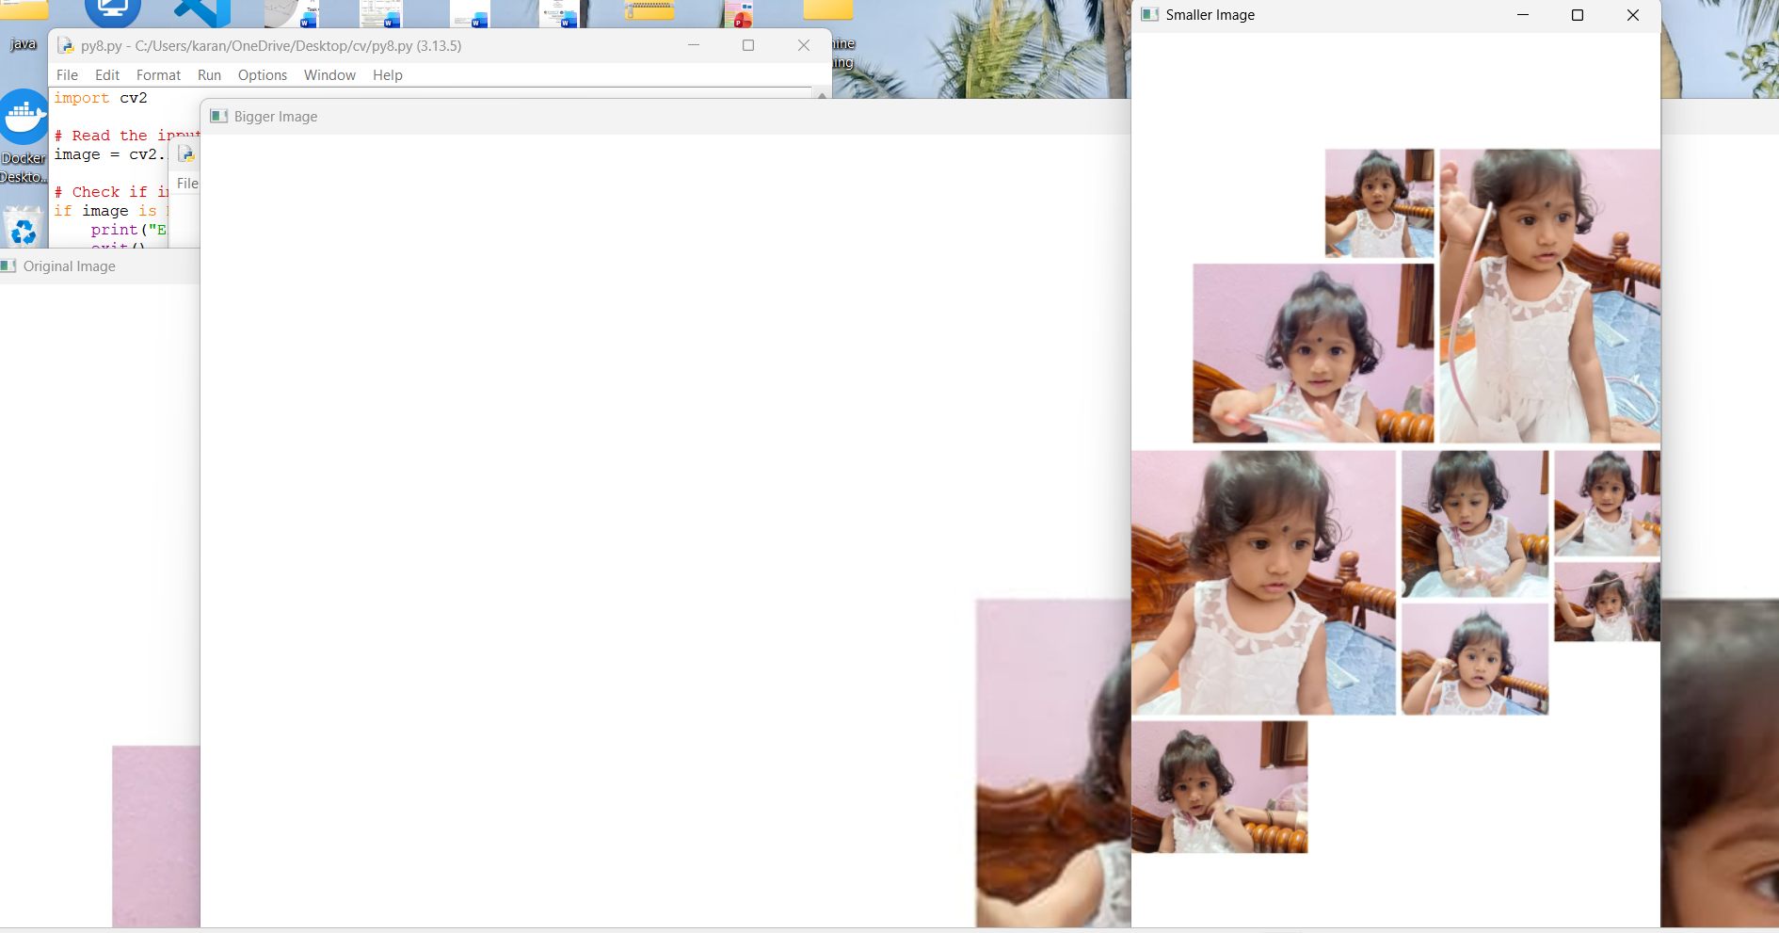
Result
The input image was successfully resized using OpenCV. The enlarged image was obtained by increasing the scale factor, and the reduced image was obtained by decreasing the scale factor. Thus, image scaling to both bigger and smaller sizes was successfully performed.

